Computer Assignment 5

Robert Bara, Zenon Matychak  
robert.bara@temple.edu, tuj21479@temple.edu

# Introduction

The purpose of this computer assignment is to take in images and create filtered images by using Discrete Time Filters. The filters are created based upon taking the Fourier Transform of the light frequencies projected onto each image and performing multidimensional convolution through MATLAB’s *imfilter* function.

# Methods

Our code for the extra credit, testing with fspecial and medfilter3 since we could not get medfilter2 to work.

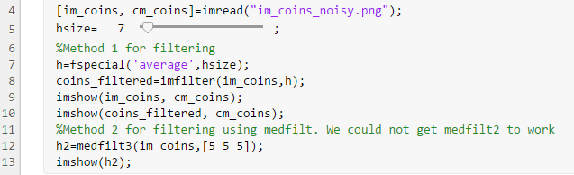

Figure . MATLAB code for extra credit

# Results

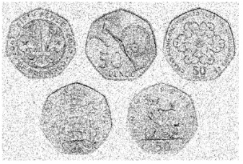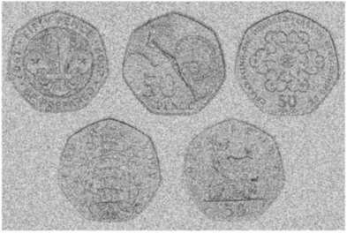

Figure . & 3. Results using fspecial and Medfilt3

# Discussion

The effect of filtering the images we passed in can be described as follows: Low pass filters seem to smooth out the edges and colors of the overall image, blending in shapes and reducing lines when increasing HSIZE. The High pass filter further defines the lines of the image and sharpens it, while also reducing color, it is the opposite of the Low pass filter. When designing the filter, HSIZE drastically changes the way the filter reacts to the image fed in. Increasing HSIZE increases the intensity of the filter by filtering all the image, as setting the parameter of HSIZE’s array filters more of the image. Increasing HSIZE outputs a filtered but blurrier image than the original when using the Low Pass filter. Increasing HSIZE creates many more peaks in the FFT Plot. The number of peaks corresponds to how filtered and distorted the image appears. Changing HSIZE increases the magnitude of the FFT and therefore when applied to each filter, the rate of filtering frequencies changes as follows. The filter acts on the original signal, it allows for a gradual decrease of residual gain in many subsequent frequencies. The image displays this effect by the colors bleeding into each other since the filter is not a perfect filter and discharges upon reaching the FFT value. The Fourier Transform of an impulse will yield a horizontal gain which the filters will charge up to. From this, a high pass filter is the result because it is created from the subtraction between the Fourier Transform of the impulse which acts as a peak gain, and the low pass filter’s transfer function; by subtracting this filter, we are omitting the band of low frequencies.

Extra Credit:

Creating a lowpass similar to that in Step 2, the first filtered image appears less grainy with random noise, however slightly blurred with less defined edges. Using medfilt3, the image appears sharper and clearer with better contrast between the background and foreground of the coins. The median filter works better in distinguishing the coins; however, it is worth noting the filter is not a perfect filter and while most of the noise is omitted, some of the grain is still present defined with the rest of the image. Median filters take the median of the neighborhood of pixels around the target pixel, dampening the difference of the dark grain pixel in relation to the others surrounding it. The Median filter is nonlinear because the result is based upon the signals of a select group of pixels around it and is not based upon the convolution of the image’s frequencies. This is the reason why our other filters appear blurrier, these lowpass filters are based upon convolution/fourier transforms.